**CSS** Guide

A brief introduction

to

***C****ascading* ***S****tyle* ***S****heets*

## 

## 

What is CSS?

Three Ways to Insert CSS

External style sheet

Internal style sheet

Inline style

Multiple Styles Will Cascade into One

CSS Syntax

CSS Comments

CSS Selector

The id Selector

The class Selector

CSS Reference

## 

## 

## What is CSS?

* **CSS** stands for **C**ascading **S**tyle **S**heets
* Styles define **how to display** HTML elements
* Styles were added to HTML 4.0 **to solve a problem**
* **External Style Sheets** can save a lot of work, stored in  **.CSS files**

A example of a simple internal CSS code:

*<html>*

*<head>*

*<title>......</title>*

***<style type="text/css">***

***body{***

***background-color:green;*** */*set background color to green*/*

***color:red*** */*set the text color to red*/*

***}***

***h1{***

***color:orange;*** */*set heading text color to orange*/*

***text-align:center;*** */*set heading text position in center*/*

***}***

***p{***

***font-size:20px;*** */*set <p> tag text size to 20px*/*

***}***

***</style>***

*</head>*

*<body>............</body>*

*</html>*

Try this link: <http://goo.gl/JnukN> to see what does CSS do in your HTML code.

* **HTML** defines **“What”** elements(text, picture, video, animation etc.) are to be displayed.
* **CSS** defines **“How”** HTML elements are to be displayed. (the style and structure)

In HTML 4.0, all in-line formatting could be removed from the HTML document to between <style>…..</style> tags in <head> tags, or stored in a separate .CSS file. **All browsers support CSS today,** but they will display the CSS style in slightly different way.

## Three Ways to Insert CSS

### 

### External style sheet

Styles are normally saved in external .css files. External style sheets enable you to change the appearance and layout of all the pages in a Web site, just by editing one single file!

For above CSS code, you can put them in separate **style.CSS** file, like the following:

***body{***

***background-color:green;***

***color:red***

***}***

***h1{***

***color:orange;***

***text-align:center;***

***}***

***p{***

***font-size:20px;***

***}***

and change your HTML code:

*<head>*

*<title> .…..</title>*

***<link rel="stylesheet" type="text/css" href="style.css" />***

*</head>*

This link: <http://goo.gl/3p1gO> will show you how the external CSS file change HTML look and style easily.

### Internal style sheet

An internal style sheet should be used when a single document has a unique style. You define internal styles in the head section of an HTML page, by using the <style> tag, like this:

*<head>*

***<style type="text/css">***

***hr {***

***color:sienna;***

***}***

***p {***

***margin-left:20px;***

***}***

***body {***

***background-image:url("images/back40.gif");***

***}***

***</style>***

*</head>*

### Inline style

An inline style **loses many of the advantages** of style sheets by mixing content with presentation. Use this method sparingly!

To use inline styles you use the style attribute in the relevant tag. The style attribute can contain any CSS property. The example shows how to change the color and the left margin of a paragraph:

*<p* ***style="color:sienna;margin-left:20px">****This is a paragraph.</p>*

## Multiple Styles Will Cascade into One

What style will be used when there is more than one style specified for an HTML element?

Generally speaking we can say that all the styles will "cascade" into a new "virtual" stylesheet by the following rules, where **number four has the highest priority**:

1. Browser default
2. External style sheet
3. Internal style sheet (in the head section)
4. **Inline style (inside an HTML element)**

So, an inline style (inside an HTML element) has the highest priority, which means that it will override a style defined inside the <head> tag, or in an external style sheet, or in a browser (a default value).

Note: If the link to the external style sheet is placed after the internal style sheet in HTML <head>, the external style sheet will override the internal style sheet!

## CSS Syntax

A CSS rule has two main parts: a **selector**, and one or more **declarations**:

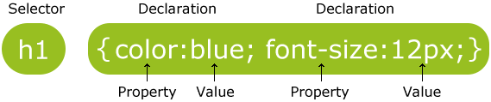

* The selector is normally the HTML element you want to style, example: <h1>, <p>, <table>,<body> etc.
* Each declaration consists of a **property** and a **value**.
* The **property** is the style attribute you want to change. Each property has a value.

A CSS declaration always **ends with a semicolon**, and declaration groups are surrounded by **curly brackets**:

***p {........}***

To make the CSS more readable, you can **put one declaration on each line**:

***p{***

***color:red;***

***text-align:center;***

***}***

## CSS Comments

Comments are used to explain your code, and may help you when you edit the source code at a later date. Comments are **not displayed** by web browsers.

A CSS comment begins with "***/\****", and ends with "***\*/***", like this:

***/*This is a comment*/***

***p***

***{***

***text-align:center;s***

***/*This is another comment*/***

***color:black;***

***font-family:arial;***

***}***

## CSS Selector

### 

### The id Selector

* The id selector is used to specify a style for a single, unique element.
* The id selector uses the id attribute of the HTML element, and is defined with a "**#**".

In your HTML code, give an ***id*** to the tag,

***<p id="para1">Hello World!</p>***

***<p>This paragraph is not affected by the style.</p>***

in your CSS code, you can use ***#*** to select the tag for styling.

***#para1***

***{***

***text-align:center;***

***color:red;***

***}***

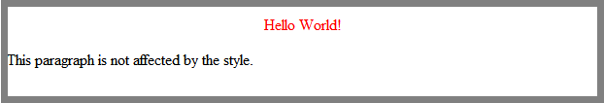

### 

### The class Selector

* The class selector is used to specify a style for a group of elements. Unlike the id selector, the class selector is most often used on several elements.
* This allows you to set a particular style for many HTML elements with the same class.
* The class selector uses the HTML class attribute, and is defined with a "**.**"

In your HTML code, give a ***class*** name to the tag,

***<h1 class="center">Center-aligned heading</h1>***

***<p class="center">Center-aligned paragraph.</p>***

in your CSS code, you can use ***.*** to select the tag for styling.

***.center***

***{***

***text-align:center;***

***}***

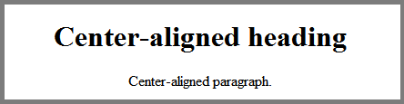

Or you can also specify that only specific HTML elements should be affected by a class.

In the example below, all p elements with class="center" will be center-aligned:

in HTML code:

***<h1 class="center">This heading will not be affected</h1>***

***<p class="center">This paragraph will be center-aligned.</p>***

in CSS code:

***p.center***

***{***

***text-align:center;***

***}***

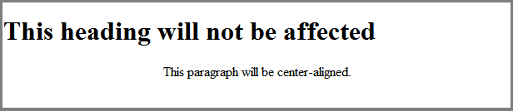

## CSS Reference

### 

|  |  |
| --- | --- |
| **Topics** | **Links:** |
| **CSS examples** | <http://goo.gl/OJsng> |
| **CSS selector** | <http://goo.gl/OdY6O> |
| **CSS Properties** | <http://goo.gl/Uichj> |
| **CSS color names** | <http://goo.gl/TO0xT> |